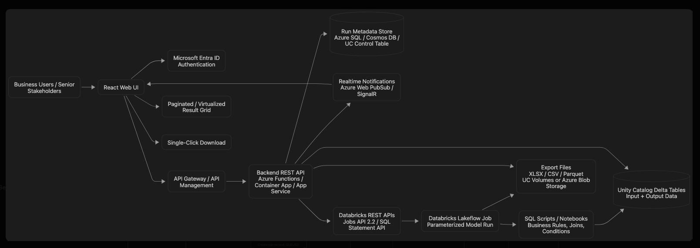

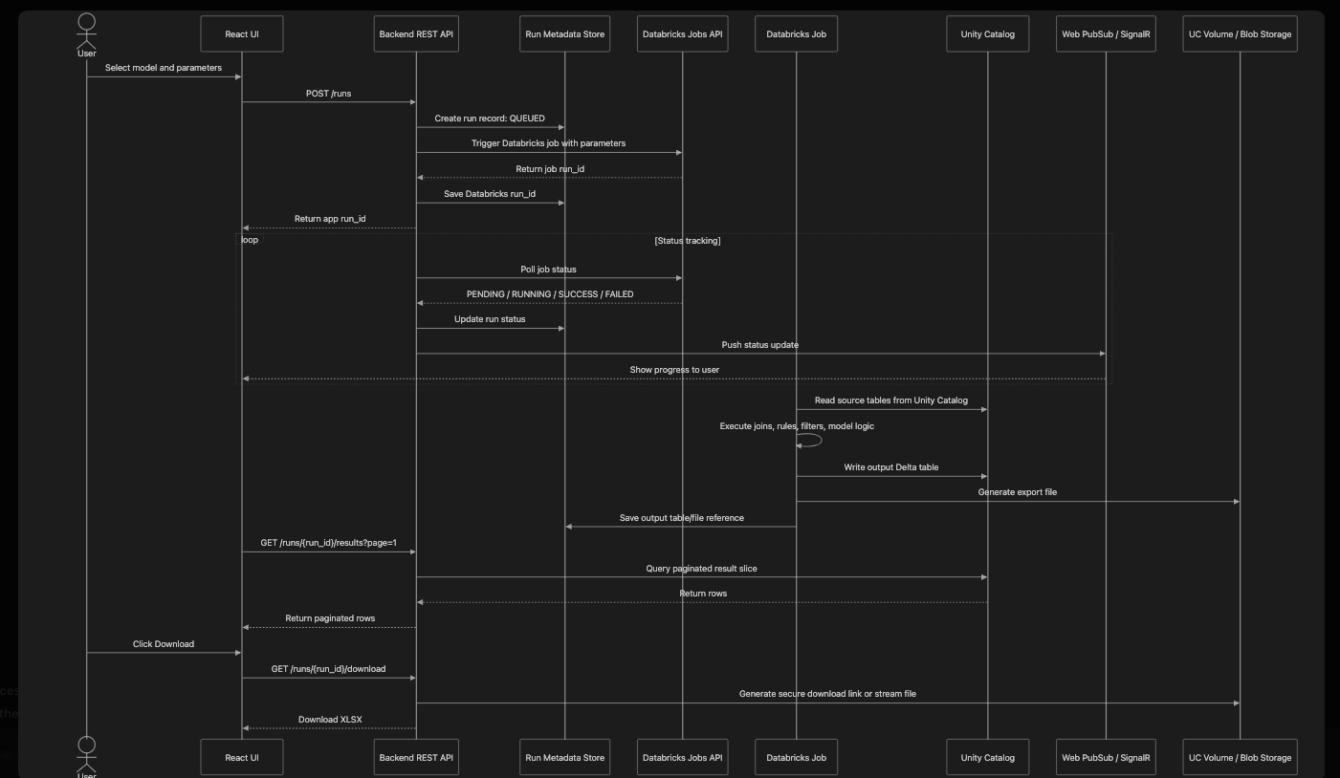

Key Design Choices
- REST API is the right interface
React should call your own REST API. The backend then calls Databricks using OAuth/service principal credentials. This protects secrets and gives you control over retries, authorization, logging, throttling, and run history.
- Use Databricks Jobs, not direct SQL from UI
For 12 min to 2 hr execution, use a Databricks Job. Direct SQL Statement API is better for smaller interactive queries, metadata lookup, dropdown values, or result pagination after the job is complete.
- Use async execution
The API should immediately return a run_id. The UI then receives progress through WebSocket notifications or polling.
- Do not load 500K+ rows into browser at once
Use server-side pagination, filtering, sorting, and a virtualized grid. The UI should show pages or slices, not the full dataset in memory.
- Generate XLSX server-side
Browser-side XLSX generation for 500K rows is risky. Also, Excel has a hard sheet limit of 1,048,576 rows. If outputs may exceed that, the app should either split sheets or offer CSV/Parquet as an additional download format.
- Keep all run history
Store every run with:
  - app run id
  - Databricks job run id
  - selected model
  - parameters
  - user
  - start/end time
  - status
  - output table name
  - row count
  - download file location
Security Considerations
- Use Microsoft Entra ID for user login.
- React never stores Databricks tokens.
- Backend uses service principal/OAuth for Databricks access.
- Use least-privilege Unity Catalog permissions.
- Store secrets in Azure Key Vault.
- Put API behind API Management with rate limits and request validation.
- Validate model parameters server-side.
- Enable audit logging for user, model, run, and download activity.
- Use private networking/private endpoints where possible.
Availability Considerations
- Host React on Azure Static Web Apps, App Service, or Storage/CDN depending on enterprise requirements.
- Backend should run on Azure Functions Premium, App Service, or Container Apps with autoscaling.
- Use retry/backoff for Databricks REST calls.
- Use Databricks job queueing and concurrency limits.
- Persist run state so UI can recover after refresh.
- Use Azure Web PubSub/SignalR for status, with polling fallback.
- Store generated files in durable storage.
Preferred POC stack would be:
React + Azure Static Web Apps + Backend REST API on Azure Functions/Durable Functions + API Management + Azure Databricks Jobs + Unity Catalog + Web PubSub + Azure SQL/Cosmos DB for run metadata.

Architecture Walkthrough Talking Points
Audience: Technical Architects, Senior Developers, and Engineering Managers | Suggested duration: 7 minutes
Purpose
Use these talking points to explain the high-level design, its principal trade-offs, and the decisions required before production implementation. The sequence follows the architecture diagram from the user channel through orchestration, Databricks execution, governed output, and operational controls.

1. Context and Workload Constraints - 45 seconds
This solution provides a governed web interface for running reinsurance analytical models hosted in Azure Databricks. The workload characteristics drive the design:
- Source datasets exceed nine million records.
- A model run can take from 12 minutes to two hours.
- A result can contain more than 500,000 rows.
- Users may execute the same model repeatedly and must retain every result.
- Users need progress visibility, paginated results, and downloadable output.
These constraints rule out a conventional synchronous request. The core architectural principle is asynchronous orchestration with durable run state.

2. Architecture Overview - 60 seconds
The primary request path is: React UI -> API Management -> Application API -> Databricks Jobs -> Unity Catalog.
Microsoft Entra ID authenticates users. The React application sends the user's access token through API Management to the backend. The backend performs business authorization, validates parameters, creates an application run record, and invokes an approved Databricks Job using a workload identity.
Databricks performs the large joins, calculations, quality checks, and export generation. Governed Delta results are written to Unity Catalog. The browser never calls Databricks directly and never receives Databricks credentials.

3. Why the Backend Is Required - 45 seconds
The backend is an intentional security and control boundary. It provides:
- Central authorization for models, runs, results, cancellation, and downloads.
- Parameter validation and idempotency to prevent duplicate expensive runs.
- API versioning, throttling, audit events, and correlation identifiers.
- Databricks credential isolation and normalized downstream errors.
- A stable application contract that prevents the UI from depending on Databricks APIs.
Direct React-to-Databricks integration would expose platform details, complicate authentication, and weaken authorization and audit controls.

4. Execution Lifecycle - 75 seconds
When a user submits a model, the UI calls POST /v1/runs with an idempotency key. The API authenticates the user, validates the model and parameters, and creates a run in SUBMITTING state. It then invokes the Databricks Jobs API and records the returned Databricks run ID.
The API immediately returns 202 Accepted with an application run ID. The request is never held open for the model to finish.
The normal state progression is SUBMITTING -> QUEUED -> RUNNING -> VALIDATING -> EXPORTING -> SUCCEEDED. Failure, timeout, cancellation, and export-warning states are explicit terminal outcomes.
Azure Durable Functions coordinates retries, timers, reconciliation, and export processing. The job therefore continues if the user closes the browser or an API instance restarts.

5. Why Databricks Jobs - 60 seconds
Databricks Jobs, or Lakeflow Jobs, are preferred over using the SQL Statement API for the complete model. The Statement API remains useful for short metadata queries and bounded result pages, but it is not the right primary mechanism for a two-hour, multi-stage execution.
- Durable asynchronous execution and lifecycle identifiers.
- Task dependencies, conditional execution, retries, and timeouts.
- Cancellation, repair runs, compute isolation, and operational history.
- Parameterized execution using version-controlled SQL, notebooks, or Python artifacts.
A representative workflow validates access and parameters, prepares inputs, executes the model, performs quality checks, publishes output atomically, creates summaries, generates exports, and finalizes the run manifest.

6. Data and Result Handling - 75 seconds
Analytical output remains in Unity Catalog as Delta data. Azure SQL stores application metadata only: run status, ownership, timestamps, model version, row count, safe errors, and output references.
This separation keeps the run-history experience responsive without coupling normal UI operations to SQL warehouse startup latency, and it avoids copying analytical rows into the application database.
Every successful result is immutable and associated with its application run ID. Later executions create new outputs instead of overwriting earlier results, supporting reproducibility, audit, and comparison.
The UI never loads the complete result. The backend provides server-side filtering, sorting, and cursor-based pagination through a Databricks SQL warehouse.
Databricks or an asynchronous worker generates export files before download. Files are stored in a Unity Catalog Volume or secured Azure Blob Storage and exposed through short-lived authorized links. Excel supports a maximum of 1,048,576 rows per worksheet, so very large outputs may require multiple sheets or CSV/Parquet alternatives.

7. Status Notifications and Resilience - 45 seconds
Azure Web PubSub provides near-real-time status updates, but push notification is not the source of truth. A notification tells the UI that state changed, and the UI retrieves the canonical record from the API.
If PubSub is unavailable, the UI falls back to polling with exponential backoff. A scheduled reconciliation process compares all non-terminal application runs with Databricks and repairs state after missed events, backend restarts, or temporary dependency failures.

8. Security Model - 60 seconds
Security operates at two layers. Application authorization controls who may discover and run a model, inspect a run, access results, cancel execution, or request a download. Data-platform authorization restricts service identities to the required Databricks jobs, Unity Catalog tables, schemas, views, and volumes.
- Human authentication uses Entra ID authorization-code flow with PKCE.
- Workload authentication uses managed identity or an Entra service principal with OAuth and least privilege.
- No personal access tokens, storage keys, or client secrets are placed in React code.
- Sensitive parameters are excluded from URLs and logs; every download is re-authorized.
- Private endpoints, Key Vault, API throttling, security headers, dependency scanning, and audited access form the production baseline.

9. Availability and Scaling - 45 seconds
The API is stateless and scales horizontally. Durable orchestration and Azure SQL retain state independently of individual API instances. Databricks job compute handles model execution, SQL warehouses handle bounded result queries, the application API handles control-plane operations, and Web PubSub carries lightweight notifications.
Concurrency limits should be enforced per user, team, and model to prevent resource exhaustion and uncontrolled Databricks cost. Queue duration, execution duration, export duration, and failure rates are monitored separately.

10. Closing and Review Decisions - 45 seconds
The POC can begin with fewer Azure components without changing the fundamental integration model. Front Door, private endpoints, Redis, and zone-redundant tiers may be deferred initially and introduced as additive production hardening.
The review should confirm:
- Azure Functions with Durable Functions versus Container Apps.
- Azure SQL versus a Unity Catalog control table for run metadata.
- Service-principal and Unity Catalog permission boundaries.
- Result retention, legal hold, and run-visibility policy.
- Databricks compute sizing, queueing, and concurrency strategy.
- Practical XLSX threshold and approved fallback formats.
- Production availability, recovery point, and recovery time objectives.
The stable design recommendation is that the UI remains lightweight, the backend owns security and orchestration, and Databricks owns heavy computation and governed analytical output.

Likely Questions and Suggested Responses
Why not use only Databricks SQL?
The workload is long-running and multi-stage. Jobs provide stronger orchestration, recovery, cancellation, task dependencies, and operational history.
Why introduce Azure SQL?
It provides responsive transactional run history without coupling normal UI operations to Databricks warehouse availability. Unity Catalog remains the analytical system of record.
Is Web PubSub mandatory?
No. It improves responsiveness, while polling and reconciliation preserve correctness.
How do we display more than 500,000 rows?
We do not transfer them all. The backend returns bounded, cursor-paginated pages with server-side filtering and sorting.
What happens if the user closes the browser?
The Databricks job and durable orchestration continue. The user can return later and retrieve the canonical state.
How do we avoid duplicate costly jobs?
Submission uses an idempotency key and normalized request hash. Ambiguous submissions are reconciled before any retry creates new work.

